⚛️ 𝗤𝘂𝗮𝗻𝘁𝘂𝗺 𝗖𝗼𝗺𝗽𝘂𝘁𝗶𝗻𝗴 𝗜𝘀𝗻’𝘁 𝘁𝗵𝗲 𝗙𝘂𝘁𝘂𝗿𝗲 — 𝗜𝘁’𝘀 𝘁𝗵𝗲 𝗡𝗼𝘄.
If you’ve been watching the quantum space accelerate, here’s your reminder: opportunities are no longer theoretical — they’re real, and organizations like QuantumBasel are already leading groundbreaking, real-world quantum projects. 👇⚛️
This visual roadmap perfectly captures what today’s quantum roles truly demand:
🔹 Strong fundamentals in Physics, CS, or Electrical Engineering
🔹 Hands-on skills with Qiskit, Cirq, PennyLane
🔹 Mastery of quantum algorithms like Shor’s, Grover’s, and VQE
🔹 Real project experience — from GitHub builds to Kaggle challenges
🔹 And increasingly… exposure to applied quantum innovation
That’s exactly why QuantumBasel stands out.
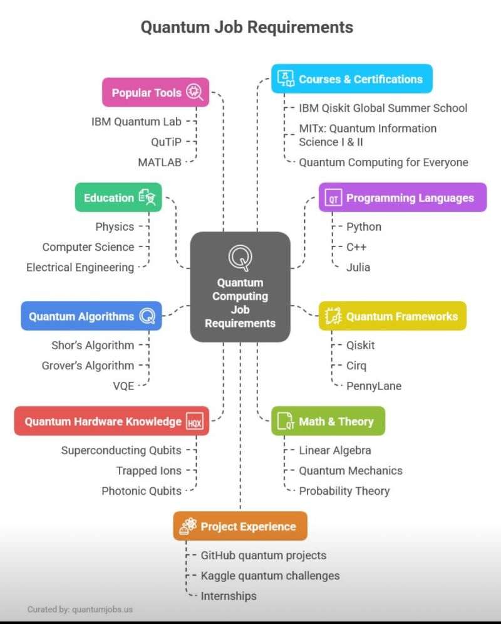Work on real projects. Align with ecosystems like QuantumBasel.

